**CHAPTER I**

**THE PROBLEM AND ITS BACKGROUND**

INTRODUCTION

Science laboratories are an essential component of science education, as they provide students with the opportunity to engage in hands-on activities and experiments that enable them to explore and understand scientific concepts in a meaningful way. According to the National Science Education Standards (NSES) published in 1996, laboratory experiences are crucial for developing scientific literacy, inquiry skills, and an understanding of the nature of science (National Research Council 23). In addition, RNS International school stated that a science lab is a workplace for the conduct of scientific research. It helps students to remember the concepts better and to transfer the experience to real-life situations. It is a facility that provides controlled conditions in which scientific research, experiments, and measurements may be performed ("Science Laboratory").

Science laboratories are critical components of research and academic institutions, and managing their equipment and resources is essential to ensuring optimal performance and productivity. However, managing laboratory inventory can be a challenging and time-consuming task, especially in larger facilities with multiple users. A comprehensive inventory and access management system can help streamline these processes and improve overall laboratory efficiency. This system can provide real-time information on inventory levels, equipment status, and usage, enabling better decision-making and resource allocation.

In addition, a science laboratory is a dynamic and constantly evolving space, with researchers and students constantly coming and going, conducting experiments, and utilizing a vast array of equipment and materials. As a result, managing inventory and controlling access to these resources can be a daunting and complex task. A comprehensive inventory and access management system for science laboratories can help streamline these processes, enabling laboratory managers to monitor inventory levels in real-time, track equipment usage and maintenance, and restrict access to sensitive materials and equipment. By implementing such a system, laboratories can improve overall efficiency, reduce waste, ensure compliance with safety and regulatory requirements, and ultimately, enhance research outcomes.

Many universities including Batangas State University ARASOF-Nasugbu have science laboratories since science laboratories are an essential component of science education, as they provide students with the opportunity to engage in hands-on activities and experiments that enable them to explore and understand scientific concepts in a meaningful way. The research locale for this study is Batangas State University ARASOF-Nasugbu, specifically its science laboratories. The university needs to implement a comprehensive inventory and access management system to help improve laboratory operations and management by providing an efficient way of managing laboratory resources, equipment, and supplies.

Traditionally, science laboratories have relied on manual systems, such as paper-based logbooks, to manage their inventory and control access to their resources. While these systems may have worked in the past, they are prone to errors, time-consuming, and difficult to manage, especially for larger facilities. For instance, manual tracking of inventory records is susceptible to errors, including loss of data, inaccurate records, and inconsistencies in data entry. On the other hand, manual control of access to resources is often inefficient and may lead to misuse, theft, and unauthorized access.

The study aims to evaluate the implementation of LabTrack in the science laboratories at Batangas State University ARASOF-Nasugbu. Specifically, the study will examine the impact of LabTrack on laboratory operations and management, including its effectiveness in tracking inventory, managing equipment and supplies, and improving access to laboratory resources. The study will also explore the challenges and barriers to the adoption and use of LabTrack, as well as the factors that contribute to its successful implementation.

BACKGROUND AND SETTING OF THE STUDY

Science laboratories are essential components in the educational system, providing a place for students to conduct experiments and learn scientific concepts. However, laboratory management can be a complex process that requires proper inventory control, equipment tracking, and access control to ensure the laboratory's safety and efficiency.

The Batangas State University Science Laboratory faces challenges in managing its laboratory. The laboratory management has difficulty tracking the inventory of chemicals, equipment, and supplies, which can lead to issues like expired chemicals and shortages of supplies. Furthermore, identifying who borrowed equipment and the condition of the equipment after use is a challenging task for the laboratory management. Monitoring access to the laboratory is also crucial for maintaining laboratory security and ensuring the safety of students and staff.

This study will be conducted in Batangas State University ARASOF-Nasugbu located at Barangay Bucana, Nasugbu, Batangas, Philippines. Batangas State University ARASOF-NAsugbu is a public educational institution with 6,475 enrolled students as of 2nd Semester AY 2022-2023.

The objective of this study is to develop a system that can effectively manage the inventory of chemicals, equipment, and supplies in the Batangas State University Science Laboratory. Additionally, the system aims to monitor equipment borrowing, identify expired chemicals and shortages of supplies, and provide access control to the laboratory.

To achieve the study's objective, we will conduct a comprehensive review of the literature on laboratory management, inventory control, and access control. We will also survey laboratory staff and students to gather information on the laboratory's current management practices and identify areas that require improvement.

Based on the findings, we will design and develop a laboratory management system that includes inventory tracking, equipment borrowing tracking, and access control features. We will test the system's functionality and usability and evaluate its effectiveness in improving laboratory management.

STATEMENT OF THE PROBLEM

The main problem of the project is to assist the Batangas State University Science Laboratory in managing and monitoring the Science Laboratory Inventory.

Specifically, the study will attempt to answer the following question:

1. What are the typical challenges that respondents encounter when managing and monitoring science laboratory equipment and chemicals?
2. What is the respondents level of satisfaction of the proposed system in terms of;
   1. Functionality,
   2. Usability,
   3. Reliability,
   4. Efficiency and,
   5. Security

3. What is the respondents level of acceptance of the proposed system in terms

of:

* 1. Inventory control,
  2. Report generation and,
  3. Data accuracy?

SIGNIFICANCE OF THE STUDY

The implementation of a comprehensive inventory and access management system like LabTrack in the science laboratories of Batangas State University can have several benefits for different stakeholders, including:

**Batangas State University**. LabTrack can help the university to improve laboratory operations, enhance efficiency, and ensure compliance with regulations. This can lead to better scientific research and education outcomes for the university.

**Students**. LabTrack can provide students with better access to laboratory resources, making it easier for them to conduct experiments and complete laboratory work. This can enhance the quality of their education and improve their learning outcomes.

**Professors**. LabTrack can help professors to better manage laboratory resources, ensuring that equipment is available when needed and that laboratory experiments run smoothly. This can improve the quality of their research and teaching.

**Science department**. LabTrack can provide the science department with a centralized database for laboratory data, making it easier to access, organize, and analyze laboratory data. This can improve the quality of scientific research and lead to better research outcomes.

**Future researchers**. The implementation of a comprehensive inventory and access management system like LabTrack can create a more efficient and effective laboratory environment, which can attract future researchers and enhance the university's research capabilities.

SCOPE AND LIMITATION OF THE STUDY

The LabTrack system is a comprehensive inventory and access management system designed specifically for the science laboratory of Batangas State University ARASOF-Nasugbu. It provides a range of features that enable lab managers and staff to efficiently manage laboratory resources, such as equipment, supplies, and chemicals, and tracking the students who borrowed equipment and entered the lab, as well as generating reports. The LabTrack system includes inventory management features, such as tracking and monitoring of lab resources, automated inventory alerts, and real-time reporting on inventory levels.

Limitation of the LabTrack system could be that it may not be able to track the usage of consumable items in real-time. Although the system can keep track of the inventory levels of these items, it may not be able to accurately monitor when and how often they are used by lab personnel. This could potentially lead to stockouts or overstocking of certain items, which could impact the efficiency of lab operations.

DEFINITION OF TERMS

This study incorporates terminologies that may be unfamiliar to some

readers; for clarification, the terms used and their explanations are as follows:

Science laboratory. An essential component of science education and scientific research, providing students and researchers with hands-on activities and experiments to explore and understand scientific concepts and phenomena. It is used in our system as a place where our system will be deployed.

Inventory management system. A comprehensive inventory and access management system that helps streamline laboratory operations and management by providing an efficient way of managing laboratory resources, equipment, and supplies. It is used in our research as one of the main features of our system.

Access control. A system of policies and procedures that control and monitor access to sensitive materials and equipment in a laboratory to ensure compliance with safety and regulatory requirements. It is used in our system as the feature of the admin side.

Comprehensive inventory. A complete record of laboratory resources, equipment, and supplies that enables laboratory managers to monitor inventory levels in real-time and track equipment usage and maintenance. The use of Comprehensive inventory in our system is to generate reports that base on the inventory.

Real-time information. Information on inventory levels, equipment status, and usage that is available in real-time through a comprehensive inventory and access management system, enabling laboratory managers to make better decisions and allocate resources more effectively. Real time will be one of our system features.

LabTrack. is a system being evaluated in research, which aims to improve laboratory operations and management by providing an efficient way of managing laboratory resources, equipment, and supplies. The Labtrack is used as the main topic or name of our system.

**CHAPTER II**

**RELATED LITERATURES**

CONCEPTUAL LITERATURE

LabTrack, a comprehensive inventory and access management system, has been specifically designed for the science laboratory of Batangas State University ARASOF-Nasugbu. This online web-based solution aims to streamline inventory and access management processes, reduce paperwork, and enhance overall efficiency. Currently, the OIC-coordinator of the science laboratory at Batangas State University ARASOF-Nasugbu follows a time-consuming manual process, involving form requests that require approval. However, with the aid of technology, a simplified and expedited solution is within reach.

Creating efficient systems often involves harnessing the benefits of inventory control. By tracking and managing inventory levels, organizations can ensure the availability of materials and products in the right quantities and at the right time. Inventory control management offers advantages such as easy storage and retrieval of materials, improved sales effectiveness, and reduced operational costs (Ogbo et al.). Proper tracking of tools and equipment borrowed by students is essential for efficient management and maintenance of laboratory resources. It guarantees appropriate usage, prompt returns, and proper maintenance. Various inventory and tracking systems can facilitate this tracking process.

Implementing an inventory and access management system in science laboratories brings numerous benefits to both institutions and students. Such a system empowers laboratories to operate more effectively by simplifying inventory tracking, improving management, saving time, and enhancing cost control (Anderson, Alex.). School laboratories play a pivotal role in the development of students' cognitive abilities. However, the lack of a practical and efficient laboratory management system has hindered their ability to support the learning process. Overcoming this challenge requires persistent efforts (Riswanto et al.).

LabTrack offers exemplary inventory and tracking solutions. One such solution is LabCheckout, a web-based tool that enables users to track equipment and manage reservations. LabCheckout maintains a comprehensive borrowing history for each item, including check-out and return dates. The system also automates reminders to borrowers, ensuring timely returns and minimizing overdue instances (Smith). Additionally, Radio Frequency Identification (RFID) technology provides another innovative solution for tracking laboratory equipment. By utilizing small RFID tags and specialized readers, LabTrack accurately tracks equipment location and usage history (Liu et al.). Furthermore, managing expired chemicals in a science laboratory is crucial for maintaining a safe and functional environment. In larger laboratory settings, this task can be challenging and time-consuming. Effective management requires regular monitoring and assessment of chemical inventory to identify and dispose of expired or hazardous chemicals appropriately (Kostrzewski et al.).

To address these challenges, the study proposes the development of a web-based application. This application will enable science laboratory staff at Batangas State University ARASOF-Nasugbu to input information on equipment and tools borrowed by students, generate comprehensive reports, and efficiently manage a large volume of laboratory usage data. Furthermore, a data dashboard could be implemented, providing real-time insights into laboratory usage and highlighting frequently utilized equipment and tools during specific periods. Such a robust system would significantly enhance inventory and usage management, ultimately improving the laboratory's overall efficiency and effectiveness.

RESEARCH LITERATURE

In the field of scientific research, laboratories serve as the primary hub for experimental work, data collection, and analysis. However, managing laboratory resources such as instruments, equipment, and supplies, can be a challenging task. Laboratory inventory management systems have been developed to help overcome these challenges, but many of them lack comprehensive functionality.

According to Max Muller, inventory management is a crucial component of a company's business activities, as it affects the financial aspects of the organization. Maintaining "the right item in the right quantity in the right place at the right time" is essential, as it can increase the company's revenue (Muller 2019).

According to McHugh, computerized inventory management systems provide numerous benefits that are difficult to achieve with traditional paper methods or in-house spreadsheets. Lab-specific solutions can be implemented rapidly with little learning curve or system adaptation. Moreover, spreadsheets and paper systems can benefit significantly from the ability to analyze inventory, item consumption, purchasing history, and other areas. If the system includes equipment tracking, it can also be used to calculate capital assets and track service history and equipment lifespan (McHugh 38-40).

Based on the study "Computerized Sales and Inventory System for Ronmon Trading" conducted by de Alday, Spino, and Ragudo in 2010, the recommended system for inventory management resulted in more efficient and accurate transaction processing compared to the manual method. The computerized system significantly reduced errors and inaccurate information while producing valuable reports with integrity (de Alday et al.).

Furthermore, computer-based systems are complex systems in which information technology plays a major role. They make work easier, faster, and more accurate, which is why automated schemes have become essential to both small and big companies that strive to provide the best possible services. Nevertheless, some businesses still prefer to stick with a system that is not integrated with technology due to computer illiterate staff and lack of funds. However, companies, especially large ones, are recommended to switch from manual to automated systems to improve the efficiency and productivity of their businesses, which will uplift the industry’s reputation. One of the most sought-after automated systems in different companies is the purchasing and inventory system, which goes hand in hand. A purchasing and inventory system is vital in every organization because a good purchase and inventory management can create excellent productivity. Primarily, inventory work consists of input, output, and restock. Input is a process of buying new products into the inventory and replacing the old products with the new ones. Meanwhile, output is a procedure of taking out the products from the inventory for sales or usage, and refill is a process of increasing the number of existing products in the inventory to fulfill the insufficient products or escalating demands. Most of the retailing market is using the traditional way in the inventory management system, where a person is assigned to check and record the stock by hand using pen and paper. It is where operations with regards to all the stock will be archived (Studymode.com).

In Addition, Espinosa, M. discusses in "CHAPTER II Review of Related Literature and Study 2.1 Review of Related Literature 2.1.1 Foreign Literature" that according to Henderson (2008), an inventory system consists of a control system used in many warehouses to monitor the location, quantity, and status of goods that are to be sold. Shipping and receiving of products are scheduled by an inventory control system. Inventory control uses barcodes and RFID tags to track specific items. An audit or physical count of inventory is used to determine the number of items in an inventory. Inventory taking is often required for accurate accounting valuation purposes. Some inventory items have barcodes attached or imprinted on them which can be read during an audit by barcode reading devices.

According to the study, "Relationship between poor documentation and efficient inventory control at Provincial Ministry of Health, Lahore," inventory control is a systematic approach to ensure the right quantity, quality, and timing of goods through reordering, storing, and locating them to achieve desired service levels (Rashid and Amirah 420). Additionally, inventory control verifies the balance, cost, and quantity of held stock, including total ordered, used, and remaining quantities, as well as the placement of the next order (Rashid and Amirah 420). The study indicates that in the past, inventory management was not treated seriously, and vagueness during planning, execution, and controlling in supply chain networks led firms towards bullwhip (Rashid and Amirah 423).

Hashim and Arifin (2013) suggested that a conventional system in product inventory involves the use of numerous forms and books to manually list out inventory, which could result in the loss or misplacement of data. They proposed that this conventional system be replaced with a user-friendly and more systematic system. Despite this, some organizations still employ manual systems for recording data processes. The introduction of the Laboratory Inventory System has improved this system (Hashim and Arifin 261-264).

In Addition, Samrand stated that the objective of his thesis was to provide a design to replace the old-fashioned manual system with a new technology-based system. The system aims to automatically identify personnel, students, and laboratory equipment for every equipment loan during a laboratory session. In order to present a systematic and practical design for automated monitoring, a solution was provided using Radio Frequency Identification (RFID) technology. An RFID-based monitoring system was designed and developed to solve the problem associated with the handling of laboratory equipment (Samrand 45).

**Local Literature**

Based on the study "Quickip: Equipment Borrowing System for Laboratory Facilities." (German, Josephine D., et al., 2021 ), The importance of continuous process improvement should not only be limited to profit-driving activities. Today, some schools still tend to overlook the importance of innovating some of their outdated processes such as manual documentation systems in laboratories, libraries, and other school facilities.

In Addition, Evangelista discusses the study conducted by Averion, Gaela, and Libo (2009) entitled “Monitoring and Inventory for discovery Mall.com”. The study states that implementing an online inventory system can minimize the difficulty of the manager in processing inventory, as the system will perform physical counting of products, stocks, and computing inventory summary. The system can also monitor the availability of products and items to prevent under stocking, over stocking, and running out of stocks.

TECHNICAL BACKGROUND

The researchers will gather pertinent information about the aforementioned issues from the science laboratory at Batangas State University ARASOF-Nasugbu. In order to develop a web-based and mobile app Inventory and Access Management System for science laboratories, the researchers brainstormed and discussed potential technology options to incorporate into the system. The researchers identified various tools, software, and technology that could be utilized in a monitoring system.

The research project is centered on IT and involves the use of various tools and technical terms, including HTML, CSS, JavaScript, XAMPP, Sublime, Apache, Lucidchart, Php, MySQL, Database, Web-based, and phpMyAdmin. The researchers applied some of these terminologies as technology in their project.

HTML stands for HyperText Markup Language. It is a standard markup language for web page creation. It allows the creation and structure of sections, paragraphs, and links using HTML elements such as tags and attributes. HTML elements are the building blocks of a web page. A tag tells the web browser where an element begins and ends, whereas an attribute describes the characteristics of an element (hostinger.com).

CSS stands for Cascading Style Sheets language and is used to stylize elements written in a markup language such as HTML. It separates the content from the visual representation of the site. The relation between HTML and CSS is strongly tied together since HTML is the very foundation of a site and CSS is all of the aesthetics of an entire website (hostinger.com).

JavaScript is a lightweight programming language that web developers commonly use to create more dynamic interactions when developing web pages, applications, servers, and or even games. JavaScript is a scripting language for creating dynamic web page content. It creates elements for improving site visitors’ interaction with web pages, such as dropdown menus, animated graphics, and dynamic background colors. (hostinger.com). To connect to the web server, researchers utilized PHP which was the focus of server-side scripting in which a server executes the instructions in a script. Then, the server provides data on request, channels the requests, and organizes the information in a database from LabTrack, A comprehensive inventory and access management system designed specifically for science laboratory needs. It not only helps in keeping track of the inventory of equipment and chemicals but also provides a platform to manage the borrower's list, equipment status, and chemical expiration date. With LabTrack, OIC-coordinator of a science laboratory of Batangas State University ARASOF-Nasugbu can easily monitor the status of the equipment and chemicals in the laboratory, ensuring their proper usage and timely replacement. Additionally, LabTrack also generates detailed reports on borrower activities, equipment status, and chemical expiration dates, providing you with an easy-to-use interface to track the laboratory's inventory and access management(developer.mozilla.org) .

XAMPP for the web server allows the researchers to test their system even

without internet access (undsgn.com). For creating a relational database system researchers used MySQL and PhpMyAdmin for handling the management of MySQL which was a popular database while for web server software, the Apache HTTP web server was employed. Sublime text editor was the software used in coding scripts in the developed system. Furthermore, a Lucid chart was used for constructing charts and diagrams forming a work breakdown structure (WBS) of the project (hostinger.ph).

THEORETICAL FRAMEWORK

The LabTrack, a Comprehensive Inventory and Access Management System for Science Laboratory system aims to address the problem of using manual encoding or traditional methods to manage the inventory and access of scientific laboratory equipment and materials. In traditional laboratory settings, personal information of borrowers is often recorded manually, which can lead to errors, inconsistencies, and delays in accessing necessary equipment and materials.

This manual process also makes it difficult to track inventory levels, monitor equipment maintenance, and generate accurate reports. The inventory management system ensures that the current amount of material is procured from time to time and that waste is eliminated completely in terms of resources idle time not put into productive work. The performance of the organization can be enhanced through a number of ways such as administrative cost (Eckert et. al.). LabTrack simplifies inventory and access management systems for science laboratories that simplifies the management process. It reduces errors and delays, improves efficiency, and enables easy tracking and monitoring of equipment usage and maintenance. LabTrack provides real-time data on inventory levels, helps with timely replenishment, and generates detailed reports for informed decision-making. It offers benefits such as a user-friendly interface, automated processes for reliability, real-time inventory data for efficiency, and high levels of security. LabTrack can increase the respondents' level of satisfaction and is a comprehensive solution to manage laboratory resources effectively.

The system would help to minimize the wastage of resources by enabling the laboratory to keep track of the expiration dates of materials, and to dispose of any expired or unused materials in a timely manner. The system would also help to reduce idle time by ensuring that all equipment is available and in good working condition when needed, thus enabling the laboratory to conduct experiments more efficiently.  
 This study proposes that a science laboratory is a complex system consisting of various interdependent components that interact with each other. The inventory and access management system is one of these components, and it interacts with other parts, such as laboratory personnel, equipment, and materials, to ensure the smooth functioning of the laboratory.

CONCEPTUAL FRAMEWORK

The conceptual framework below presents the method used in this study to get

its intended output using IPO (input, process, and output).







Figure 2.1 Research Paradigm on the LabTrack: A Comprehensive Inventory and Access Management System for Science Laboratory

Figure 2.1 illustrates the conceptual framework for the Inventory and Access Management System for Science Laboratory of Batangas State University ARASOF-Nasugbu. The system aims to improve the management and monitoring of laboratory resources, including equipment, supplies, and chemicals, as well as tracking the students who borrow equipment and enter the laboratory. By processing the information, the system is designed to produce more efficient and accurate outputs. This study seeks to replace the University's previous manual process with a more effective approach to laboratory resource monitoring.

For input, it will gather the needs and requirements for an inventory and access management system for the science laboratory. Feedback from laboratory managers and administrators will be obtained to ensure that the system aligns with their needs and expectations. The available technologies for building the system will be researched and evaluated to identify the most suitable technology for the system.

For the processes, it covers all aspects of the system development life cycle, starting from collecting information and data to generating conclusive recommendations for the implemented system. The approach comprises processes such as requirements gathering, system design, development, testing, and feedback from end-users. The ultimate goal is to deliver a system that is fully operational, efficient, and meets the expectations of the laboratory staff and students.

For output, it will illustrate how the system will be designed to enhance the manual managing and monitoring process of laboratory resources, such as equipment, supplies, and chemicals, and tracking the students who borrowed equipment and entered the science laboratory. The system will aim to provide a more efficient and accurate approach to monitoring laboratory resources, replacing the manual process previously used in the University.

SYNTHESIS

LabTrack is a specialized computerized system designed for inventory and access management in scientific laboratories. It provides a comprehensive solution for tracking laboratory inventory, managing access to equipment, and generating reports. In contrast, Max Muller's statement emphasizes the general concept of inventory management and its impact on a company's financial performance. While LabTrack focuses on optimizing the inventory and access management process in scientific laboratories to improve efficiency and productivity.

Both LabTrack and computerized inventory management systems in general offer benefits such as efficiency, accuracy, and the ability to generate valuable reports. However, LabTrack's focus on laboratory-specific solutions sets it apart from other inventory management systems. It is designed specifically to meet the needs of scientific laboratories and provides features such as sample tracking, access control, and reporting for equipment maintenance.

Similarly, the study "Computerized Sales and Inventory System for Ronmon Trading" and the discussion on LabTrack both emphasize the benefits of computerized inventory management systems over manual methods. However, the focus of the "Computerized Sales and Inventory System for Ronmon Trading" study is on sales and inventory specifically, whereas LabTrack is focused on laboratory equipment tracking and management.

LabTrack also emphasizes the importance of inventory management in scientific laboratories, with a focus on equipment tracking and access management. Like the study on the Provincial Ministry of Health, LabTrack aims to provide a systematic approach to inventory control, ensuring that equipment is available when needed and that users have access to the right equipment at the right time. However, unlike the study on the Provincial Ministry of Health, which focuses on the negative consequences of poor documentation on inventory control, LabTrack emphasizes the benefits of computerized inventory management systems over manual or paper-based methods.

In addition, the study "Quickip: Equipment Borrowing System for Laboratory Facilities" highlights the importance of process improvement in school facilities such as laboratories, which still rely on manual documentation systems. This issue is addressed by the LabTrack system, which provides a comprehensive inventory and access management solution for scientific laboratories. However, the study focuses specifically on equipment borrowing in laboratory facilities, while LabTrack aims to provide a comprehensive inventory and access management solution for all scientific laboratories.

In conclusion, inventory management plays a crucial role in a company's success. The use of computerized inventory management systems is highly recommended for businesses, as they provide various benefits, including efficiency, accuracy, and valuable reporting. Inventory control is a systematic approach to getting the right quantity, quality, and time of goods with reordering, storing, and locating the goods by achieving desired service levels.

**CHAPTER III**

**DESIGN AND METHODOLOGY**

This chapter explains how the research will be conducted, including the various steps and information required to develop the system. The information is presented using diagrams, figures, and requirements.

RESEARCH DESIGN AND METHODS USED

To achieve the study's aims and objectives, the researchers will use the descriptive method, which involves acquiring data and comprehending research material to address any inquiries about the current state of the investigation. The researchers will utilize the descriptive approach to calculate statistical measures such as averages, frequencies, and other computations. Essentially, the descriptive method aimed to quantify and analyze variables that can be counted.

The chapter also discussed the research methods and procedures that would be beneficial in evaluating the proposed system, LabTrack: A Comprehensive Inventory and Access Management System for Science Laboratory of Batangas State University ARASOF-Nasugbu.

To guarantee a prosperous and consistent project, the researchers will use an agile development process. This approach to development establishes the necessary steps and procedures for implementing a system. The researchers found this style of presentation advantageous since it provided them with a solid framework to work with when designing the system.

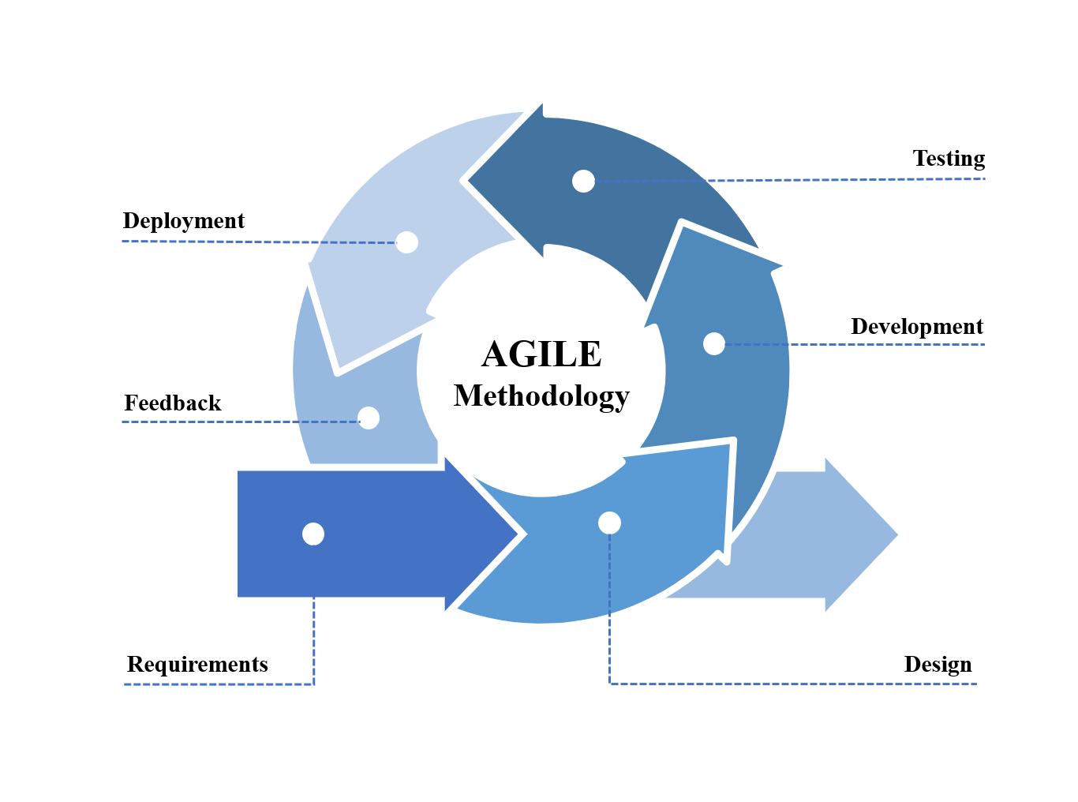

Fig. 3.1. Agile Methodology

Source:https://iphtechnologies.blogspot.com/2019/09/benefit-of-agile-method-for-software-development.html

Figure 3.1 illustrates the different phases and processes involved in using the agile development methodology to finish a project. These phases include requirements gathering, design, development, testing, deployment, and feedback.

Requirements Phase

During the Requirements phase, the researchers will conduct brainstorming sessions to identify potential problems that could be addressed through the development of a system. As a result, they conceived the idea of a monitoring system for the Science Laboratory of Batangas State University ARASOF-Nasugbu. Furthermore, they will gather information from the institution to determine the specific requirements of the proposed system. These requirements will be used as a basis for designing and developing the system, which will involve stakeholders and end-users throughout the process to ensure that the final product meets their needs and is usable in practice.

Design Phase

In the design phase, the researchers will create various output and interface options as suggested by the OIC-coordinator of a science laboratory at Batangas State University ARASOF-Nasugbu. These include sketches, flowcharts, and prototypes of the develop system. The system's design is intended to be user-friendly and, therefore, they utilized a CSS framework to establish a basic structure for the system's design, which incorporated grids and interactive user interface patterns.

Development Phase

During the development phase of A Comprehensive Inventory and Access Management System for Science Laboratory of Batangas State University ARASOF-Nasugbu, the researchers will commence the back-end project development using programming languages such as PHP and MySQL. This stage necessitates the development team to possess proficient coding and composing skills to resolve any issues that arise until the desired functionalities are accomplished. The researcher’s primary focus will be on creating the back-end components of the system, which will include the management of the database.

Testing Phase

During the testing phase, the development system will undergo comprehensive evaluations to verify its proper functionality. The development team will conduct multiple rounds of testing to ensure that the system is secure, reliable, and user-friendly before it is deployed to the production environment. This stage will be crucial in identifying and resolving any potential issues or defects in the system, ensuring that it meets the requirements and design specifications outlined in earlier stages. The researcher’s primary objective will be to ensure that the system under development is fully functional and meets the desired quality standards before it becomes available to users.

Deployment Phase

During the deployment stage, the develop system is made available to the users, providing them with access to the comprehensive inventory and access management system for the Science Laboratory of Batangas State University ARASOF-Nasugbu. The researchers will actively collect feedback from users during this phase, which they would utilize to identify areas for improvement and future iterations of the system. The primary objective of this phase is to provide a system that met the needs of the users while also being scalable and adaptable to future requirements.

Feedback Phase

The review phase will mark the final stage of the agile methodology, where the effectiveness of the proposed system will be evaluated to determine if it meets the intended user's needs. During this phase, the system will receive constructive criticism from users' feedback, which will be used to provide recommendations for enhancing its functionality. The objective of the review phase will be to ensure that the system is fully operational, reliable, and meets the end-users' needs while also being adaptable to future requirements.

DEVELOPMENT PROCESS

The development process for the develop system will include the utilization of testing and review methods, which were both critical in facilitating the improvement and enhancement of the system. These approaches will allow the development team to identify and address any issues that arose, ensuring that the system functioned correctly and met the specified requirements. By using a systematic approach, the researcher’s were able to refine the system iteratively until it will be deemed effective and user-friendly. The inclusion of testing and review methods was crucial in ensuring that the final product was of high quality and met the expected standards.

Testing Process

Testing process will be a fundamental process for evaluating the functionality and quality of the system that will be proposed. The process will involve running the system to identify any potential gaps, bugs, or incomplete conditions that may not align with the actual requirements. By performing testing, we will be able to effectively reduce the time and cost associated with rework, as any issues that arise can be detected and resolved early on.

Debugging Process

Debugging process will be a critical process that follows testing. Once testing is completed, we will search for any potential bugs or defects in the system that will be proposed. The aim of debugging will be to identify and fix any issues that may prevent the system from performing its intended functions. During the debugging process, The developer team will carefully analyze the system to identify and locate any bugs that may have been found during testing. The developer team will then take the necessary actions to provide a solution for each bug, ensuring that the system will function as intended.

Validation Process

After the debugging process, the validation process will play a critical role in demonstrating that the system that will be proposed meets the user requirements during the proposal stage. The aim of the validation process will be to ensure the completeness of the system, and to confirm that its desired outcome has been achieved. We will carefully evaluate all system operations to ensure that they are functioning properly. The system will undergo a thorough testing and debugging process to ensure that it is accurate and of good quality. Once the validation process is completed, we will have the confidence that the proposed system meets the desired standards and specifications, and that it will effectively serve its intended purpose.

PROGRAMMING PROCEDURE

System Architecture  
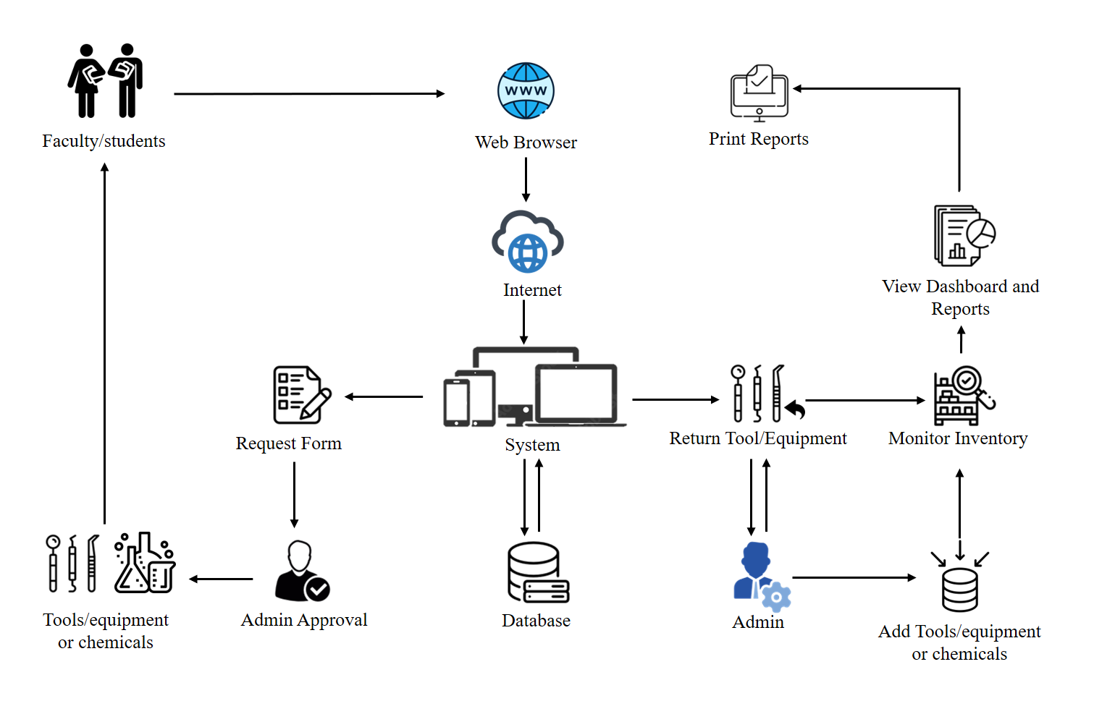

Figure 3.2. System Architecture of the System

Figure 3.2 depicts the system architecture that has been chosen for the research project, and this architecture aids researchers in defining the structural behavior and additional perspectives of the system that will develop. Using their account the faculty/students are able to log in to the system. After logging in, the faculty/students will be presented with three options: either to borrow tools and equipment, request chemicals, or return tools and equipment. When borrowing tools and equipment or requesting chemicals the faculty/students needs to fill up a form and submit it for approval to the admin. Once approved by the admin, the borrowed tools and equipment or the requested chemicals will be provided to the faculty/students. When returning tools and equipment, the faculty/students will only need to provide the items that were borrowed, which will then be returned to the inventory by the admin. The admin also adds or input tools, equipment or chemicals, monitors the inventory, views reports, and has the capability to print reports.

Requirements Analysis

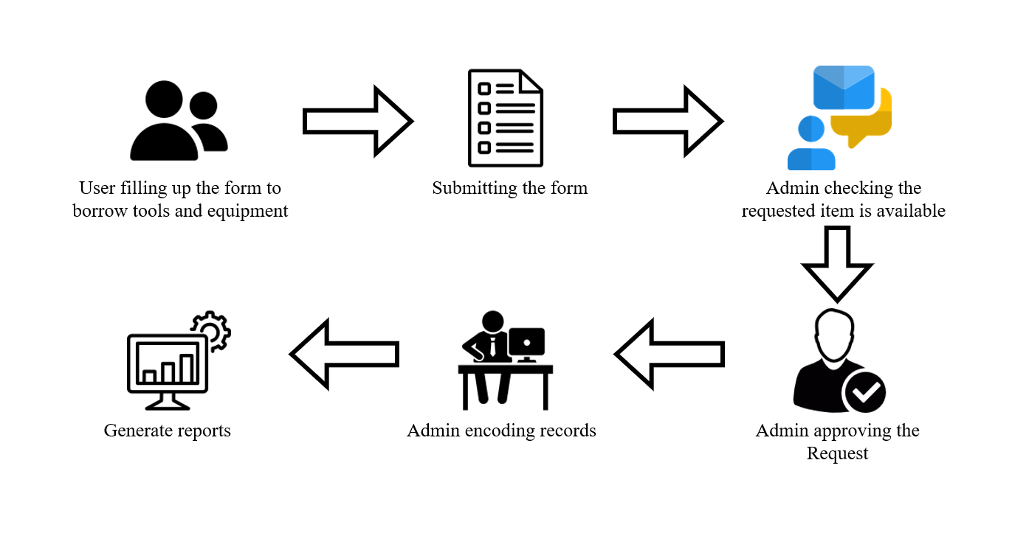

Figure 3.3 Requirement Analysis of the System

The developers of LabTrack will conduct a requirement analysis to determine user expectations for the system, as depicted in Figure 3.3. The figure outlines the current manual procedure for borrowing tools, equipment or requesting chemicals where the user must prepare and fill out a form with necessary information and submit it to the admin. Then, the admin checks for tools, equipment or chemical availability and allows the user to borrow or acquire it. Finally, the admin generates reports based on the borrowed tools, equipment or acquired chemicals, user information, and the borrowing date. LabTrack aims to automate and streamline this process by providing a comprehensive inventory and access management system for scientific laboratories.

Use Case Diagram

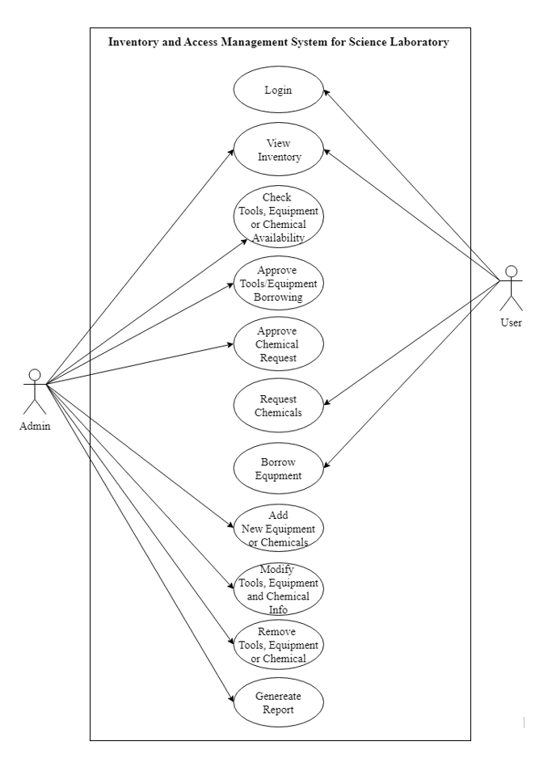

Figure 3.4. Use Case Diagram of the System

The LabTrack system's use case diagram (Figure 3.4) displays the interactions of different actors with the system through web systems. The system includes two actors: Admin, and User . Each of them can log in to the system. The User/Borrower can search and request equipment, while the Admin can manage the equipment's details and availability, including adding categories to tools,equipment or chemicals, manage the system's information, generate reports, and monitor notifications for expired chemicals.

Context Diagram

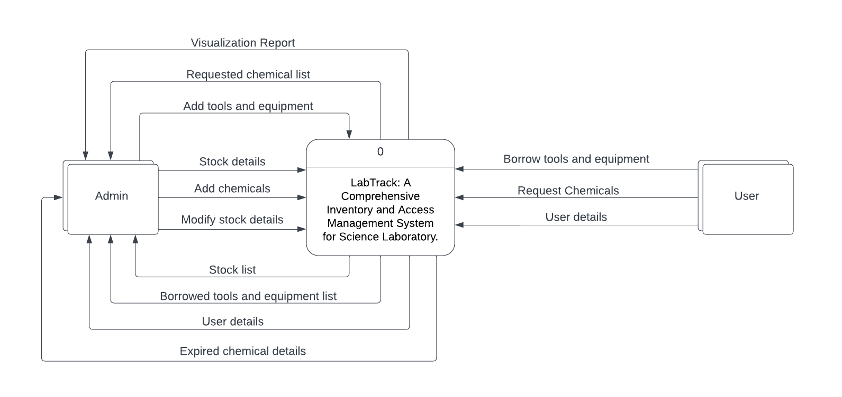

Figure 3.5 Context Diagram of the System

Figure 3.5 presents the context diagram of the system, depicting the flow of data within the system and the resulting output will be generated in response to input from various entities. Inside the rectangular box, two (2) entities are identified as admin and user. The square at the center represents the overall features and processes encompassing the input to output across all entities.

Data Flow Diagram

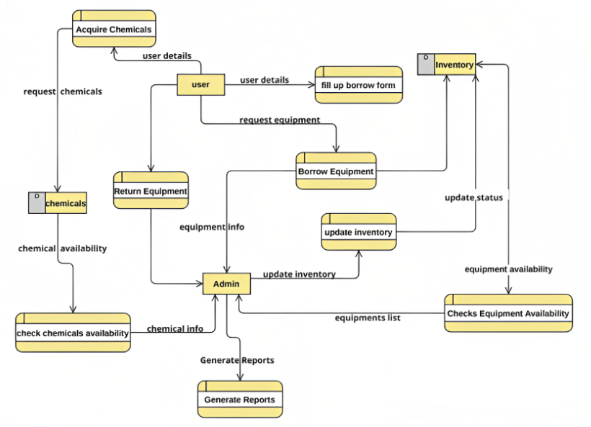

Figure 3.6 Data Flow Diagram

The presented Figure 3.6 exhibits the data flow diagram for the system that will develop and elucidate the process of data movement throughout the system's cycle. The diagram encompasses all relevant entities, such as the system's users and administrator. It provides a clear representation of the system's data flow, which is crucial for understanding its functionality and identifying potential areas for improvement in the future.

Entity-Relationship Diagram

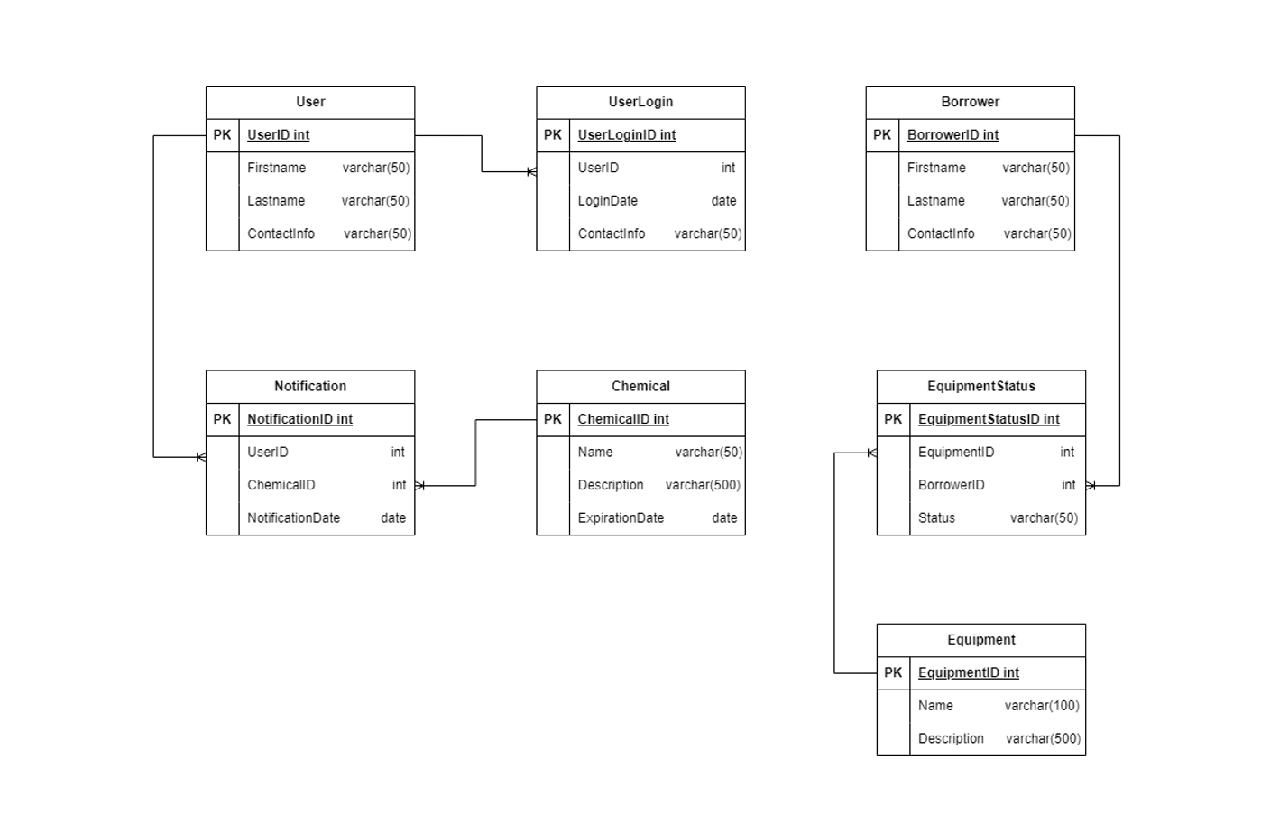

Figure 3.7 Entity Relationship Diagram

Figure 3.7 shows the table that will be needed, the relationships between each table, the attributes of each table, and the overall structure of the database to be implemented in the development of the system. This entity relationship diagram is a model that serves as the visual representation of the relationship between entities.

HARDWARE AND SOFTWARE NEEDED IN THE DEVELOPMENT

Hardware Needed

The hardware requirements for the web system and application will be contributed to successful designing and programming the develop system

.

Table 3.1

Hardware Needed of the laptop for the Development

| **Hardware** | **Specification** | **Function** |
| --- | --- | --- |
| Random Access Memory (RAM) | 8 GB | RAM is your computer or laptop's short-term memory. It's where the data is stored that your computer processor needs to run your applications and open your files. |
| Processor | 2.10 GHz | The processor, also known as the CPU, provides the instructions and processing power the computer needs to do its work. |
| Monitor | 1366 x 768 monitor | Monitor is also called a Visual Display Unit (VDU).computer monitor is an output device that displays information in pictorial or textual form. |
| Mouse | Wireless USB Mouse | The mouse is a small, movable device that lets you control a range of things on a computer. |
| Keyboard | Wired Keyboard | A keyboard is for putting information including letters, words and numbers into your computer. |

Table 3.1 provides a list of recommended hardware specifications for a laptop that will be used to develop the system. The hardware requirements include Random-Access Memory (RAM), Processor, Monitor, Mouse, and Keyboard, which are essential components for the successful completion of the project.

Software Needed

The software requirements for the web system and application will contribute to designing and programming for the system that will be developed.

Table 3.2

Software Needed in the Development

| **Software** | **Specification** | **Function** |
| --- | --- | --- |
| Programming Language | PHP, HTML,CSS | PHP is for dynamic web pages, HTML structures content, and CSS controls visual presentation of web pages. |
| Integrated  Development  Environment | Sublime Text 3, Visual Studio Code | Sublime Text 3 and Visual Studio Code are popular code editors for web development with features like language support, customizable UI, and plugins/extensions to improve the development process. |
| Database | MySQL | MySQL is a popular open-source relational database management system used to store and manage data for web applications and other software systems. |
| Web Server | XAMPP | XAMPP is an open-source tool for local web server development and testing. |

Table 3.2 shows several software tools and technologies that will be used in developing a comprehensive inventory and access management system for the science laboratory of Batangas State University ARASOF-Nasugbu. These include programming languages such as PHP, HTML, and CSS, code editors like Sublime Text 3 and Visual Studio Code, the database management system MySQL, and the web server software XAMPP. These tools will be used to create a user-friendly web-based interface, manage the system's database, and test and deploy the system on a local web server.

INSTRUMENTATION

The researchers employ survey questionnaires as the primary instrument for data gathering. The main respondents are the students and faculties of Batangas State University ARASOF-Nasugbu who acquire or borrow science tools, equipment and chemicals from the science laboratory. The survey will utilize the Likert Scale (5 points) and the responses gathered will be analyzed using methods in descriptive analytics. These responses were valuable in optimizing and enhancing the features and functions of the system that will be developed. To ensure compatibility with the system requirements, the capstone adviser will validate the questionnaires that will be utilized in the survey. Overall, the research team utilizes a professional and systematic approach in gathering and analyzing data to achieve their research objectives.

PREPARATION AND EVALUATION

The researchers will conduct a rigorous preparation process in anticipation of the evaluation of the development of the system. They will utilize a survey questionnaire form that is widely distributed to gather feedback from users on the acceptability, satisfaction, reliability, efficiency, and security of the system's functionality. The goal was to gather comprehensive data that would aid in enhancing the system and making it more user-friendly while meeting their requirements.

To evaluate the system, the researchers will use the Likert scale (5) to measure the respondent's level of acceptability and agreement with the system. The scale featured values ranging from 1 to 5, with 5 representing the highest value and 1 being the lowest. The researchers will use this scale to compute the respondent's level of satisfaction and determine whether they agreed or disagreed with the system's various functions.

i = interval

h = highest value in the questionnaires

l = lowest value in the questionnaires

t = total number of preset options in the questionnaires

Likert Scale = i=h-l

t

Table 3.3: Guideline Interval for Level of Acceptance

| **Scale** | **Mean Range** | **Descriptive Equivalent** |
| --- | --- | --- |
| 5 | 4.21-5.00 | Highly Acceptable |
| 4 | 3.41-4.20 | Moderately Acceptable |
| 3 | 2.61-3.40 | Acceptable |
| 2 | 1.81-2.60 | Slightly Acceptance |
| 1 | 1.00-1.80 | Not Acceptable |

The evaluation utilized Table 3.3, which featured a scale that was appropriately designed with an adequate mean range and descriptive equivalent. This scale was instrumental in determining the level of acceptability among the respondents. By utilizing this method, the researcher is able to gather comprehensive data on the respondents' level of satisfaction and agreement with the system, using a systematic and reliable approach.

Table 3.4: Guideline Interval for Level of Satisfaction

| **Scale** | **Mean Range** | **Descriptive Equivalent** |
| --- | --- | --- |
| 5 | 4.21-5.00 | Highly Satisfied |
| 4 | 3.41-4.20 | Moderately Satisfied |
| 3 | 2.61-3.40 | Satisfied |
| 2 | 1.81-2.60 | Slightly Satisfied |
| 1 | 1.00-1.80 | Not Satisfied |

Table 3.4 displays the levels of intensity of responses from the survey participants, with each scale number being assigned a descriptive equivalent and a mean range. The researchers utilized descriptive statistics to provide a concise summary, either numerically or visually, of the data gathered through the Likert Scale method. This allowed them to analyze the responses and draw meaningful conclusions about the attitudes and perceptions of the survey participants.

Sample Size Determination

The participants of the study include the students of Biology, CAS(physics), CAS (Chemistry) and, CTE the researchers also include the Faculties of Batangas State University ARASOF-Nasugbu Campus. A total of (150) respondents composed of forty eight (48) students from Biology , twenty six (26)CAS students from Physics, thirty five (35) CAS students from Chemistry, fourteen (14) students from CTE and twenty seven(27) Faculties members from Batangas State University ARASOF-Nasugbu Campus will participate in the study. They will be asked to utilize and evaluate the system.

Sampling Procedure

The sampling method that the researcher will use is stratified sampling for probability sampling. The researchers will use stratified sampling in this study to get an idea of the perspective of students and faculties on the develop system which is the: LabTrack: A Comprehensive Inventory and Access Management System for Science Laboratory.

Participants of the Study

The participants of the study include the students of Biology, CAS(physics), CAS (Chemistry) and, CTE the researchers also include the Faculties of Batangas State University ARASOF-Nasugbu Campus. A total of (150) respondents composed of forty eight (48) students from Biology , twenty six (26)CAS students from Physics, thirty five (35) CAS students from Chemistry, fourteen (14) students from CTE and twenty seven(27) Faculties members from Batangas State University ARASOF-Nasugbu Campus

Table 3.5

Guideline Interval for Questionnaire

| **Respondents** | **Number** |
| --- | --- |
| Biology | 48 |
| CAS (Physics) | 26 |
| CAS (Chemistry) | 35 |
| CTE | 14 |
| Faculties | 27 |
| Total: | 150 |

Table 3.6 shows the distribution of the study participants, who are the students of Biology, CAS (physics), CAS (Chemistry) and, CTE the researchers also include the Faculties of Batangas State University ARASOF-Nasugbu Campus.

WORK CITED

Anderson, Alex. "Laboratory Inventory Management System to Improve Your Lab’s Efficiency." LinkedIn, www.linkedin.com/pulse/laboratory-inventory-management-system-improve-your-labs-anderson?fbclid=IwAR1_-Ovah-YPUjhq_M5ZRBAgKhEdtOgjdtaFC7KwLKVMuHkzYLO0x0pCXP0.

De Alday, M., Spino, G., & Ragudo, R. "Chapter 2 | Related Literature | Sales and Inventory System." Itsourcecode.com, 2010, itsourcecode.com/fyp/chapter-2-related-literature-sales-and-inventory-system/.

Eckert, Scott A. "Inventory Management and Its Effects on Customer Satisfaction." Journal of Business and Public Policy, vol. 1, no. 1, 2007.

Espinoza, M. (n.d.). CHAPTER II Review of Related Literature and Study 2.1 Review of Related Literature 2.1.1 Foreign Literature.

German, Josephine D., et al. "Quickip: Equipment Borrowing System for Laboratory Facilities."

Hashim, N. M. Z., and N. A. M. M. Arifin. "Laboratory inventory system." International Journal of Science and Research (IJSR), vol. 2, 2013, pp. 261-264.

Hostinger. "The Hosting Platform Made for You - Go Online With Hostinger." Hostinger, hostinger.com.

Kostrzewski, K. D., Dvorak, C. D., Szepe, K. C., & Lammers, K. R. (2019). "Chemical management in academic research laboratories: A comprehensive approach." Journal of Chemical Health and Safety, vol. 26, no. 3, pp. 5-12.

Liu, S., Zhang, G., Yu, Y., & Yang, X. (2016). "Design of the RFID-based laboratory equipment management system." Journal of Physics: Conference Series, vol. 756, no. 1, 012046.

McHugh, Thomas M. "Computerized inventory management systems help labs stay in control." MLO: Medical Laboratory Observer, vol. 43, no. 7, 2011, pp. 38, 40.

MDN Web Docs. developer.mozilla.org.

Muller, Max. Essentials of inventory management. HarperCollins Leadership, 2019.

Ogbo, Ann I., and Wilfred I. Ukpere. "The impact of effective inventory control management on organisational performance: A study of 7up bottling company nile mile enugu, nigeria." Mediterranean Journal of Social Sciences, vol. 5, no. 10, 2014, pp. 109.

Rashid, Aamir, and Noor Aina Amirah. "Relationship between poor documentation and efficient inventory control at Provincial Ministry of Health, Lahore." American Journal of Innovative Research and Applied Sciences, vol. 5, no. 6, 2017, pp. 420-423.

Riswanto, et al. "School Laboratory Management Information System." Journal of Physics, IOP Publishing, Nov. 2019, https://doi.org/10.1088/1742-6596/1361/1/012068.

Samrand, Elyasizadeh. "Automated Monitoring System." Automated Monitoring System Designing a Laboratory Equipment Tracking System, 2016, pp. 45. www.theseus.fi/bitstream/handle/10024/114694/Samrand_Elyasizadeh.pdf?sequence=1.

Smith, C. (2016). "Labcheckout: A web-based tool for tracking laboratory equipment and managing reservations." Journal of Laboratory Automation, vol. 21, no. 5, pp. 746-753.

"UndsgnTM - ThemeForest Power Elite Author Creator of the Popular Uncode WordPress Theme." UndsgnTM, 14 Sept. 2022, undsgn.com.

"Computer-Based Inventory System." StudyMode, 10 Aug. 2021, www.studymode.com/essays/Computer-Based-Inventory-System-401903.html.